# RELAY SWITCHER USER GUIDE

For build instructions please see six4pix.com/relays

## Introduction

Relay Switcher allows you to control electrical devices such as solenoids, motors, relays, LEDs and light bulbs using MIDI messages.

It is ideal for sequencing electromechanical musical instruments, controlling light shows from your DAW, making crazy robotic sound art installations or just about anything else you can think of!

Relay Switcher has eight SPDT (single pole double throw) relays

Each relay can be configured to be switched based on the following conditions

* MIDI notes (with optional velocity range filter)
* MIDI continuous controller message (with selectable value range)
* MIDI program change (can set all outputs with a single message)

You can control the switch pulse duration based on how long the trigger condition lasts (e.g. how long a MIDI note is held) and a selectable amount of time.

The configuration options are selected using a form on a web site, which then encodes them into a MIDI System Exclusive (Sysex) file that is sent to the switcher to reconfigure it. The settings are retained at power-off

## The LEDs

* The PWR LED is on all the time the board has power. If you are powering the board and the LED is off, check the position of the PWR SEL jumper (see below)
* The ACT LED flickers when there is MIDI activity. It also blinks slowly in midi lockout mode (see below)
* Eight LEDs on the relay module itself show when each relay is activated

## The Button

The button on the Relay Switcher has the following functions

* A short press will reset all the outputs to their power-on state
* A long hold will cause the switcher to go into midi-lockout mode. The activity LED will regularly switch on and off and all MIDI input will be ignored. This mode is useful if you have multiple switchers connected to a common MIDI input and only want to access one of them at a time (e.g. for sending a configuration sysex)
* Holding the button at power up causes the switcher to enter bootloader mode, which allows new firmware to be installed over MIDI. Do not do this if you simply want to load a configuration patch!

## The Configuration Web Form

The Relay Switcher is configured using the same configuration form as the MIDI Switcher device. This can be accessed at the following URL

<http://six4pix.com/switcher/patch.asp>

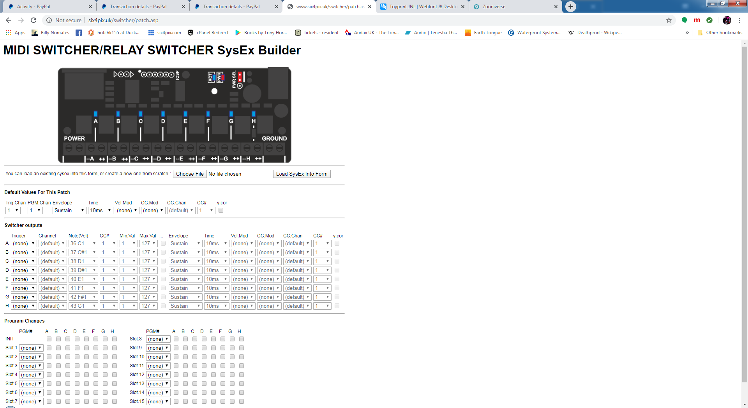

The page has three sections

* The Default Values section allows common settings to be defined just once and referenced from multiple other places, saving time and repetitive entries
* The Switcher Outputs section allows the trigger condition and pulse shaping for each of the eight outputs to be defined
* The Program Changes section allows combinations of outputs to be switched on in response to specific MIDI program change messages

At the bottom of the page is a button that submits the form and downloads a sysex file that can be sent to the switcher using a DAW or Sysex manager program such as MIDI-OX (Windows) or Sysex Librarian (Mac). The form also lets you upload an existing Sysex file and display or edit its content.

## MIDI Note Trigger

When an output is set up to switch based on a MIDI note, it switches on when the MIDI note starts playing. Depending on settings, the output switches off when the note stops playing, or after a period of time. This will be explained later

Here is an example of how a note trigger is set up using the configuration web page

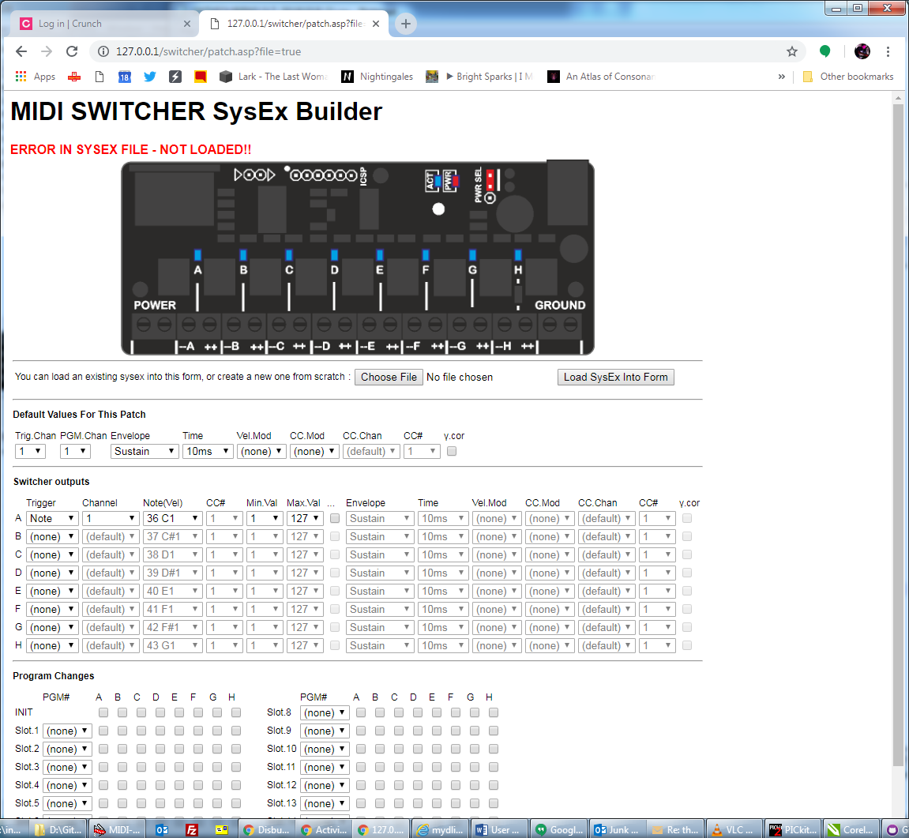

In this case a C1 note (C note, octave 1) on MIDI channel 1 will trigger output A. This particular note is MIDI note number 36.

### Velocity Filtering

As well as pitch information, MIDI note messages have a “velocity” (i.e. how hard a key was hit), which is a number from 0 (note off) to 127 (full velocity)

The MIDI switcher lets you check the velocity so you can (for example) only trigger the output if the velocity is above a certain level or between certain bounds.



For a note trigger the “Min.Val” and “Max.Val” refer to the note velocity. By default this is set to 1-127 so that any velocity higher than 0 (note off) will trigger the output (i.e. note on)

### Default Trigger Channel

A common scenario is that each output will be triggered by different notes on the same MIDI channel, but you might want to change that MIDI channel easily. For this reason the MIDI Switcher supports a default MIDI channel for Triggers. Select (default) as the channel for each output that uses the default trigger channel, e.g.

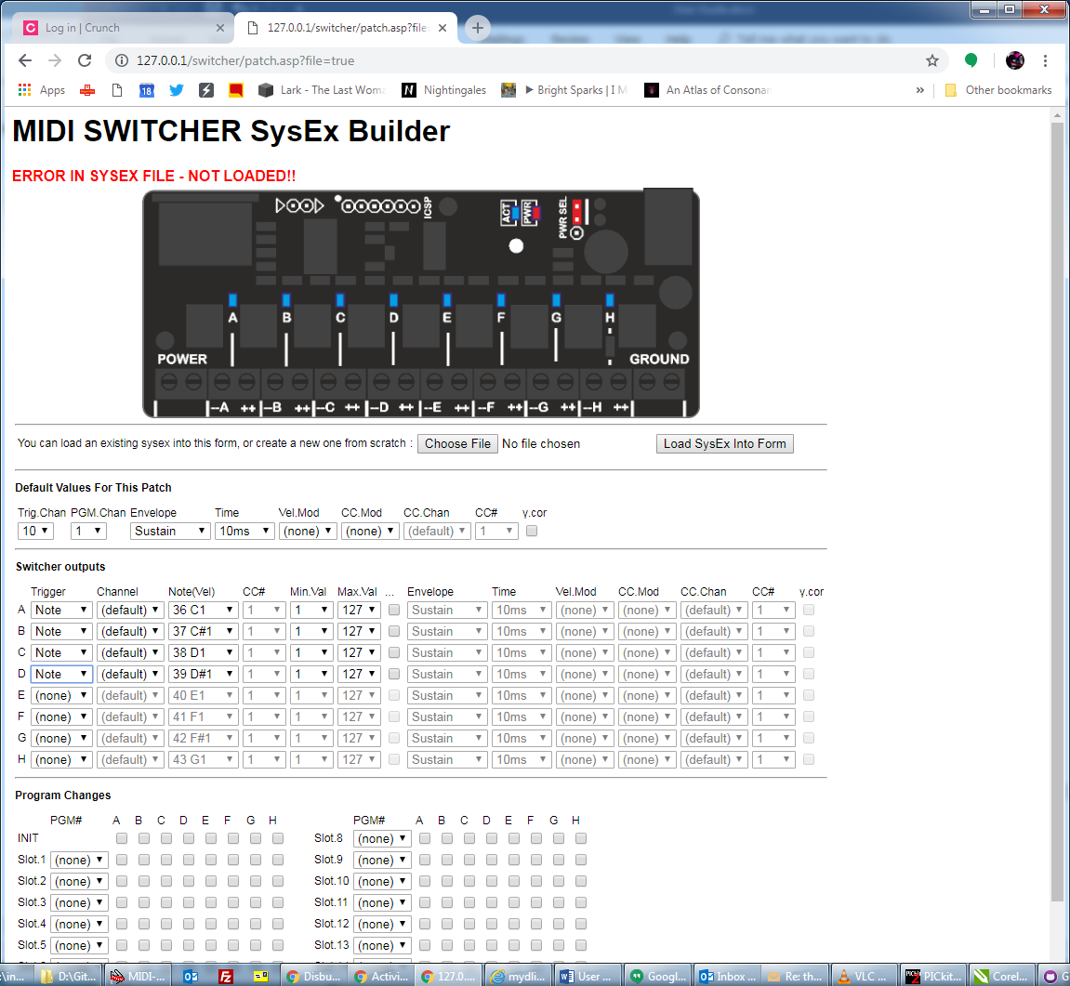

## MIDI Continuous Controller (CC) Trigger

When an output is set up to switch based on a MIDI CC, it switches on when a CC message is received that matches the controller number and where the controller value is between specified limits.

Here is an example of how a CC trigger is set up using the configuration web page

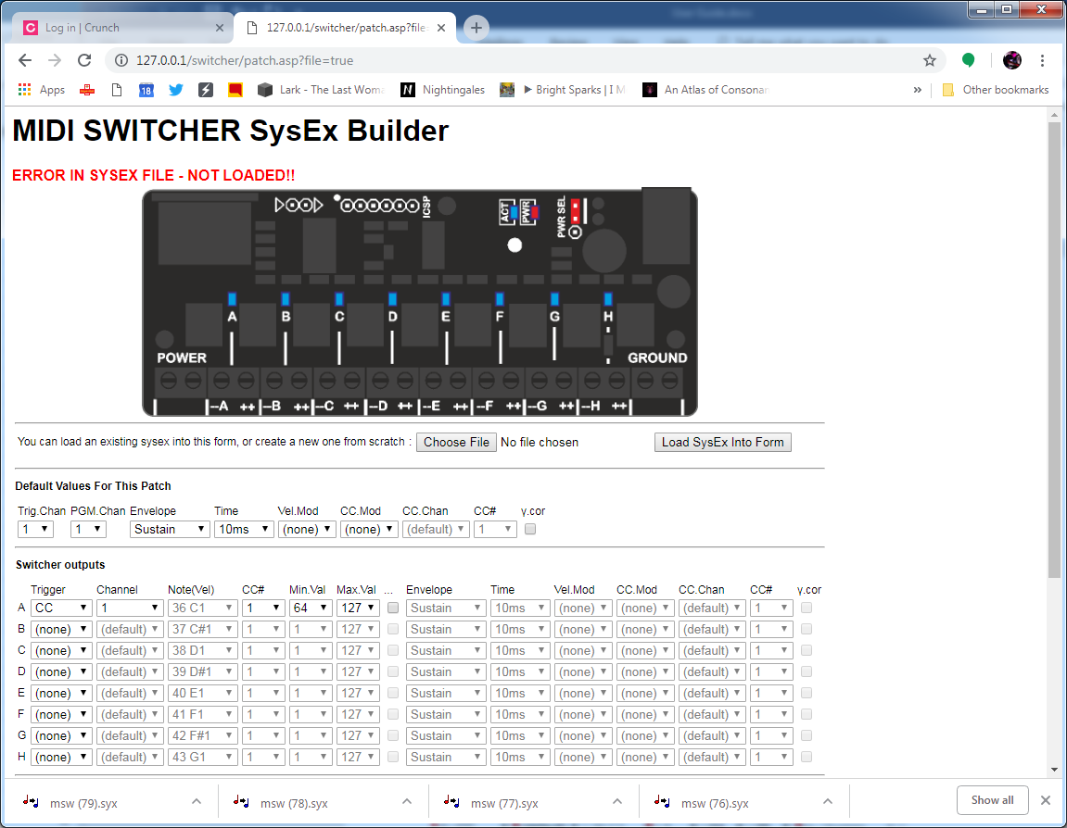

In this example, the switcher output is triggered on when CC#1 (modulation wheel) on MIDI channel 1 is between 64 and 127 (i.e. is greater than or equal to 64).

A CC trigger condition starts when the CC first has a value within the specified range and lasts until the CC has a value outside the range.

Multiple outputs can reference different ranges for the same CC and the default channel works for CC based triggers in the same way as for notes. For example

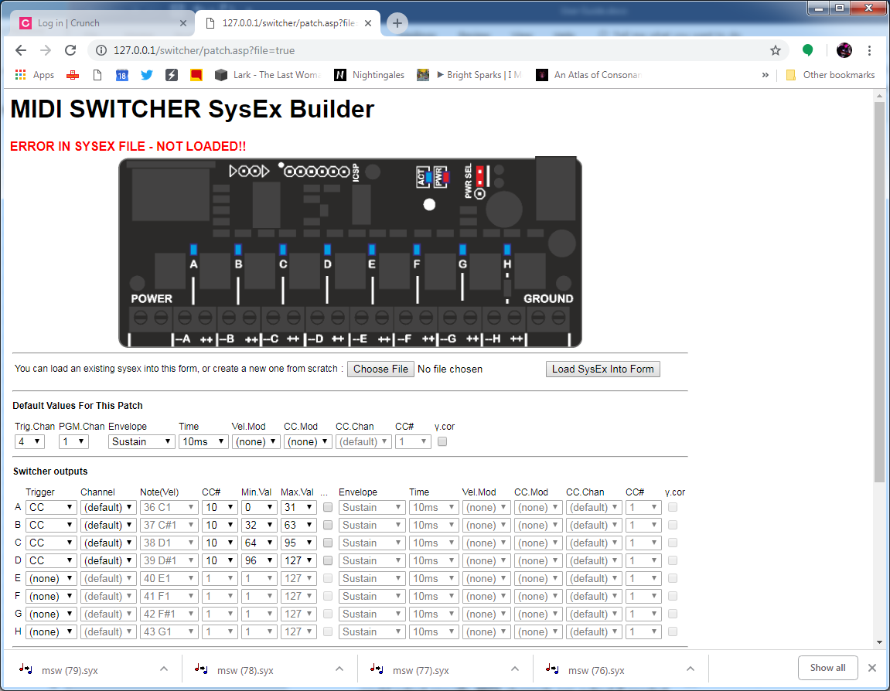

CC #10 on MIDI channel 4 will trigger outputs A, B, C and D depending on the value of the controller.

## Program Change Trigger

The Relay Switcher is able to listen for Program Change messages (these messages are usually used to select a patch on a synth). A program change message has a MIDI channel and a program number 0-127.

To trigger on program change messages you first need to configure one or more outputs in PGM trigger mode and select the PGM MIDI channel in the default section. Only outputs selected for PGM mode will respond to program change messages.

There are a total of 15 user-defined slots available to match program change messages. When a MIDI program change message matches the channel and program number for a slot, outputs be “triggered” or “untriggered” based on the selections in that PGM slot. Only outputs in PGM trigger mode will be affected, even if you check the boxes for other outputs.

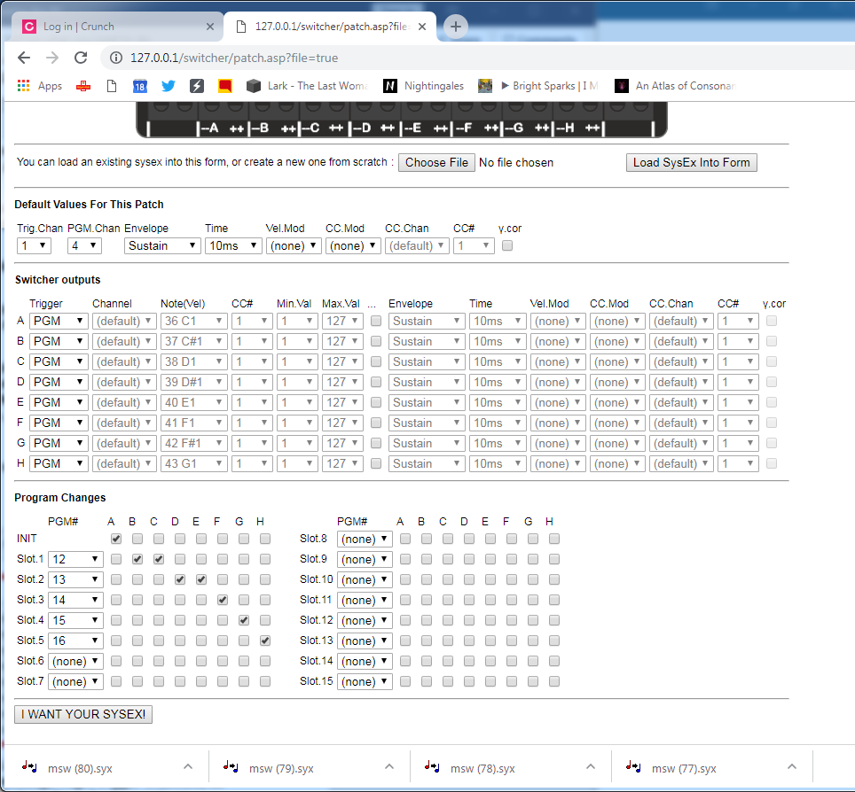

Program change messages which do not match any slot are ignored. If multiple slots match the same program number only the first will be actioned.

Program change triggers are still subject to pulse shaping. To have the outputs remain on continuously until another program change switches them off, they should be in the “Sustain” envelope mode.

The INIT settings are triggered at power on or when the outputs are reset.

## No Trigger Required!

The “Always” trigger mode means that a given output is triggered at power on and when the reset button is pressed. By setting the envelope type to Sustain, this means the output is on all the time.

This can be useful if you simply want to control the power of an output using a CC and without having to send a note message to trigger it.

## Pulse Duration

The outputs of the Relay Switcher turn “on” as soon as their selected trigger condition is met.

However, there are several settings that control the time it takes for the output to turn off again.

In the simplest scenario, the output is switched on for the duration of the trigger condition. For example, a key on a MIDI keyboard might be pressed then released and the Relay Switcher responds as follows



In some situations this might be all we need, but in others we might have specific requirements about pulse length – for example a solenoid controlled beater might hit a drum “softly” if triggered for 50ms and “hard” if triggered for 200ms.

From a sequencer, we could send our MIDI notes with exactly the correct “note on” duration, but from a MIDI keyboard it would be much more useful to use the MIDI velocity to change the duration so that if we press the key harder it will activate the output for longer.

In that case the actual length of the note as played is not important. Instead we want the output to be switched for up to 200ms depending on the note velocity. The MIDI switcher enables use to do this, for example:

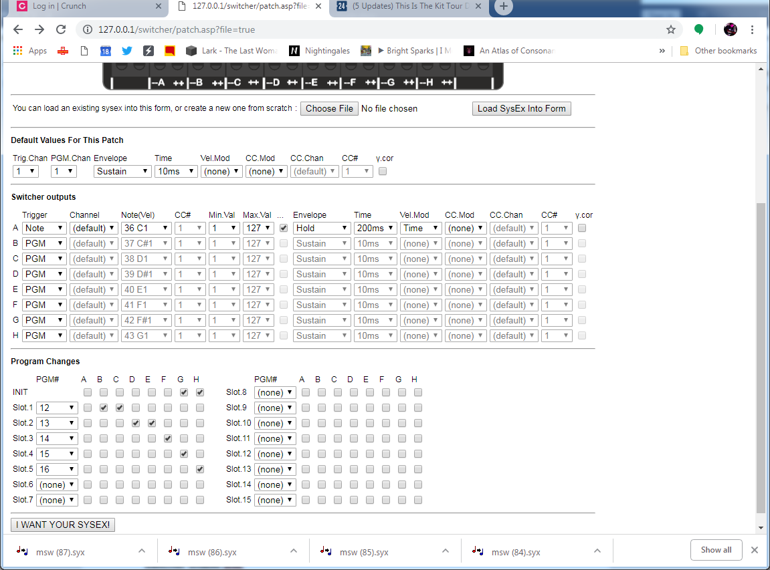

Here the “Hold” setting for “envelope” means that the output is switched based on the selected Time only, rather than the time the MIDI note is played for. There are several envelope options that will be explained below.

### Sustain Envelope

In this mode, the length of the switching pulse is controlled only by the length of the trigger condition and the hold time is not used.

|  |  |
| --- | --- |
|  |  |

### Hold Envelope

In this mode, length of the switching pulse is controlled only by the hold time and the length of the trigger condition is not used. The trigger condition might last a longer or shorter period than the hold time but the output is always switched on for the hold time

|  |  |
| --- | --- |
|  |  |

### Hold->Sus(tain) Envelope

In this mode, length of the switching pulse is controlled first by the hold time and then by the remaining length of the trigger condition. The output is therefore switched for the longest of either the trigger condition or the hold time.

|  |  |
| --- | --- |
|  |  |

### Sus(tain)->Hold Envelope

In this mode, length of the switching pulse is controlled first by the trigger condition and then by the hold time. The output is therefore switched for the total of the trigger condition time and the hold time.

|  |  |
| --- | --- |
|  |  |

### Release Envelope

*This mode is for the transistor based MIDI switcher and is not so useful on the Relay switcher.*

### Sus(tain)->Rel(ease) Envelope

*This mode is for the transistor based MIDI switcher and is not so useful on the Relay switcher.*

### Gamma Correction

*This setting is for the transistor based MIDI switcher and has no use on the Relay switcher.*

### Default Pulse Length Settings

The Relay switcher provides an easy way for multiple outputs to share the same pulse shaping settings, saving them from having to be selected individually for every output.

For a given output, if the checkbox to the left of the pulse shaping settings is not checked then the default settings in the top section of the form are applied to that output.

If the box is checked then the output has its own settings, which must be entered in the fields following the checkbox.

In this example outputs 1 and 3 are using the default settings but output 2 has its own defined

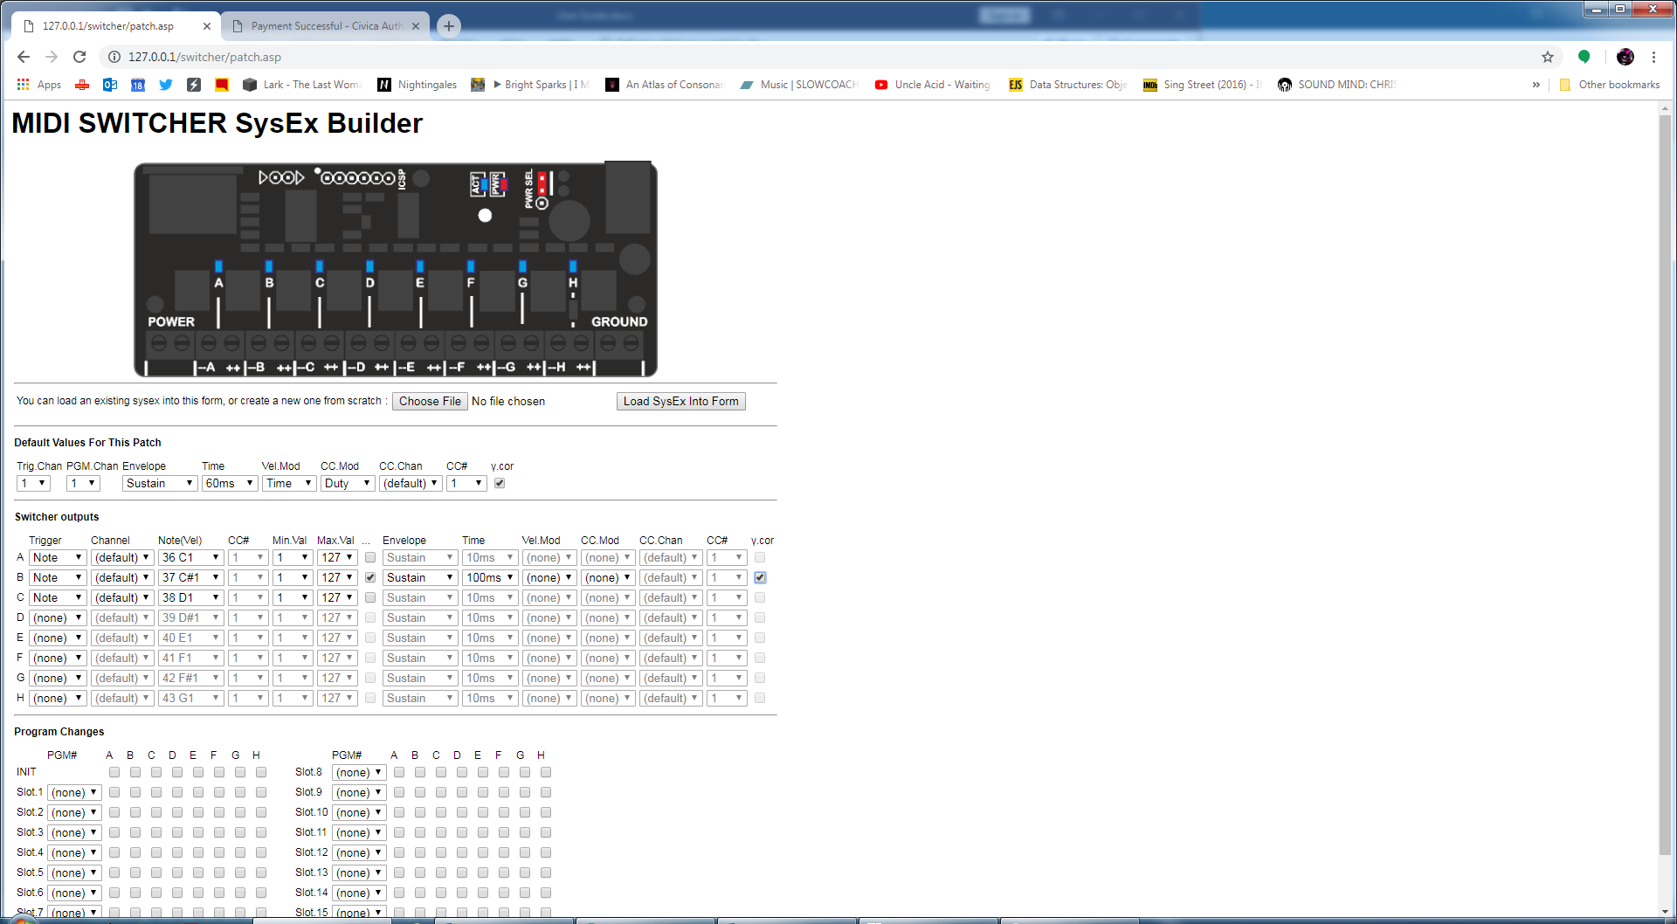

## Connecting the Switcher

The relays outputs can control power to loads such as

* Solenoids
* Motors
* Light Bulbs and LEDs

They can also be used to switch signals such as audio.

The relays are rated for switching mains electricity however **I do not advise this unless you are a qualified electrician or can have a qualified electrician check your work before you apply power… Connecting mains power to this device is done at your own risk.**

### Connecting Loads

Each relay has three terminals; a common terminal (the middle one), a normally open (NO) terminal and a normally closed (NC) terminal. These are marked (beside the relay output terminal blocks) by the symbol shown in black in the following image



When the relay is not activated, the COM terminal is connected to the normally closed (NC) terminal.

When the relay is activated, the COM terminal is connected to the normally open (NO) terminal.

Therefore, in most cases you connect the relay as a switch in your circuit, using the COM and NO terminals as shown below. In this case the light bulb would be switched on when the relay is activated



## Working with Multiple Switchers

In some situations, you might need to switch more than eight outputs. In these cases, you can use multiple Relay Switcher modules, each configured to listen out for its own triggers, then you can send the same MIDI input to each of the switchers using a MIDI splitter.

Configuring multiple splitters can be awkward when they are sharing a MIDI input, since they will all receive Sysex files

To help in this situation, there is a “MIDI Lockout” feature…if you press and hold the reset button for about 1 second the activity LED will start to flash regularly and the switcher will ignore all incoming MIDI information. By setting all but one switcher to this mode, you can program just that one switcher. Press the reset button again to return to normal.